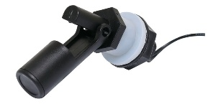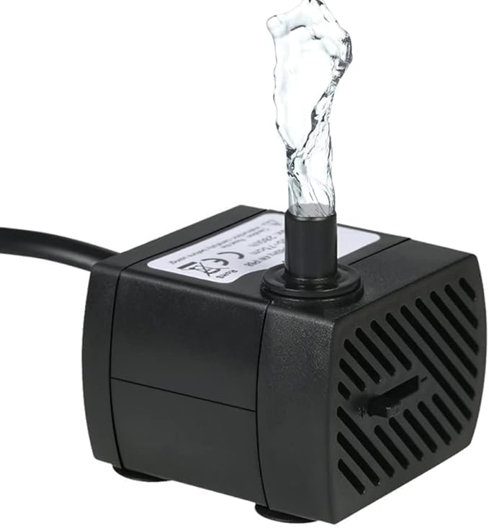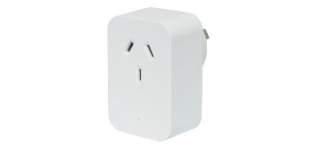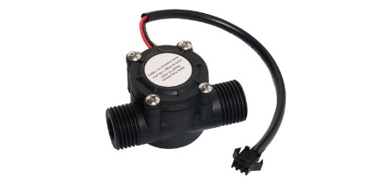

**Pump**

**Override**

**Switch**

**Reservoir**

**Critical**

**HFS**

**Reservoir**

**Warning**

**HFS**

**In**

**Flow Meter**



**Adafruit IO**

**+**

**MQTT Broker**



**Cloud Platform (Adafruit IO)**



**Alert Notifications**

**Subscribe**

**Publish**

**Every 30s or on change**

**Alert Notifications**

**ESP32 S2 Microcontroller**

* **Debouncing**
* **MQTT connect**
* **Pump shutdown**

Output LED

1. In Flowmeter
2. Return Flowmeter
3. Pump Status
4. Reservoir Warning
5. Reservoir Critical
6. Pipe Overflow

1 2 3 4 5 6

**LED Indicators**

**Pump**

**OUTPUTS**

**INPUTS**

**Pipe Overflow**

**VFS**

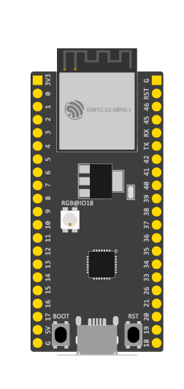

**Return**

**Flow Meter**

**Software Architecture Diagram**